
School Council Minutes of Meeting

Date: |  | 13/11/23 | Location: | House 2
Time: |  | 2pm | Location: | House 2
Present: |  |  |  | Gemma Sayce  Amanda Willis  Rachel Phillips  Alex Spooner  Amber Leyshon  Keiran Rees  Harli Jones  Lakendra Chambers-Jenkins  Kara Fender  Kyan Hopkins
Additional attendees: |  |  |  | Ryan Duford
Apologies: |  |  |  | Dean Draper  Ossian Comerford
Discussion: |  |  |  | Actions:
1 | Reminder of rules for School Council and expected behaviours.  Introduce School Council members. |  |  | No action required
2 | Mr Duford –  Curriculum areas |  |  | What curriculum areas do you enjoy the most?  Surfing, mechanics, swimming, Forest Schools, Hairdressing, Gardening, residential trips  All children agreed that these activities provided excellent opportunities for children across the school. The children said that they would like to have more of these opportunities.  If there is funding available what would you like to see more of?  More sports  More clubs  Coding / animation if you don’t like outdoors  Residential trips for everyone even if you can’t afford to go
3 | Lunchtime clubs |  |  | Lunchtime club rota discussed  Maximum 8 per club  Sports club also offered on the Muga organised by Mr Wilkins  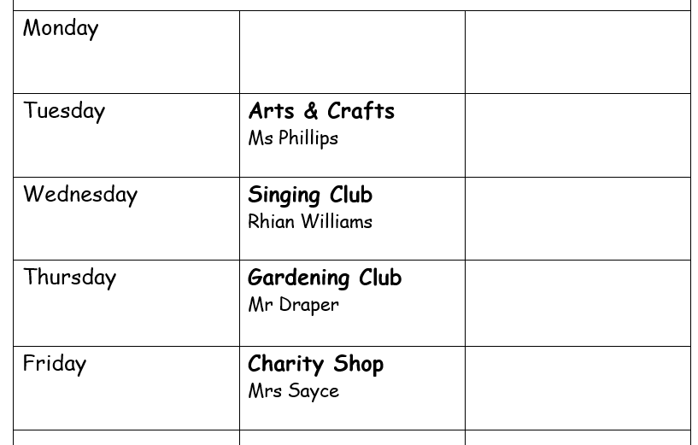  Action: School Council members to create class survey and find out who would like to join.
4 | Ms Phillips Well – being feedback  What works well?  What can we do better? |  |  | Open door policy – discuss things that happen inside and outside of school.  Bullying – no bullying policy. Talk to teachers if you witness any bullying  What do we do well at Ysgol Hendrefelin in terms of wellbeing?  Activities  The Muga  Memory Garden as a quiet space  What can we do better?  Equipment for the yard – KS3 / KS4 box.  Ability to use trampolines  Gym equipment  Action: Feedback from classes
5 | Organise Christmas Party |  |  | Date TBC – 21/12/23??  Christmas jumpers  Different activities in different rooms depending on which you would like to do  DJ  Christmas cooking  Christmas crafts  Christmas movie  Christmas colourings
6 | Safeguarding |  |  | N/A
7 | Any other business |  |  | Complete lost property box

